- Get products. (GET)
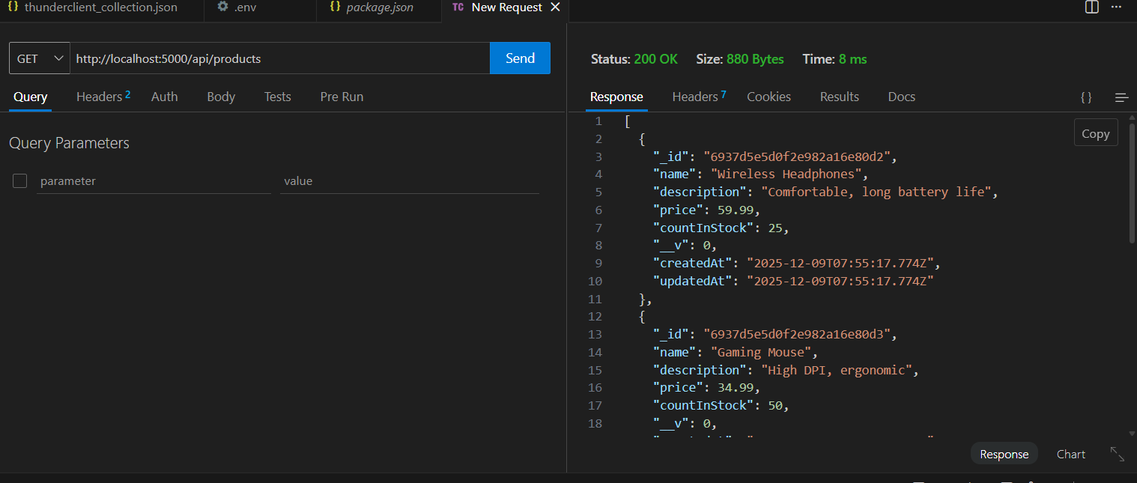
- Registration of user. (POST)
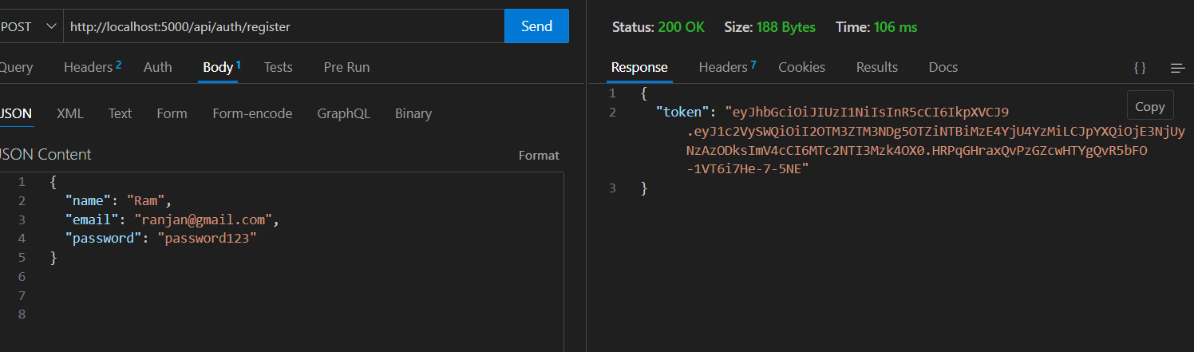
- Get product by id. (GET)
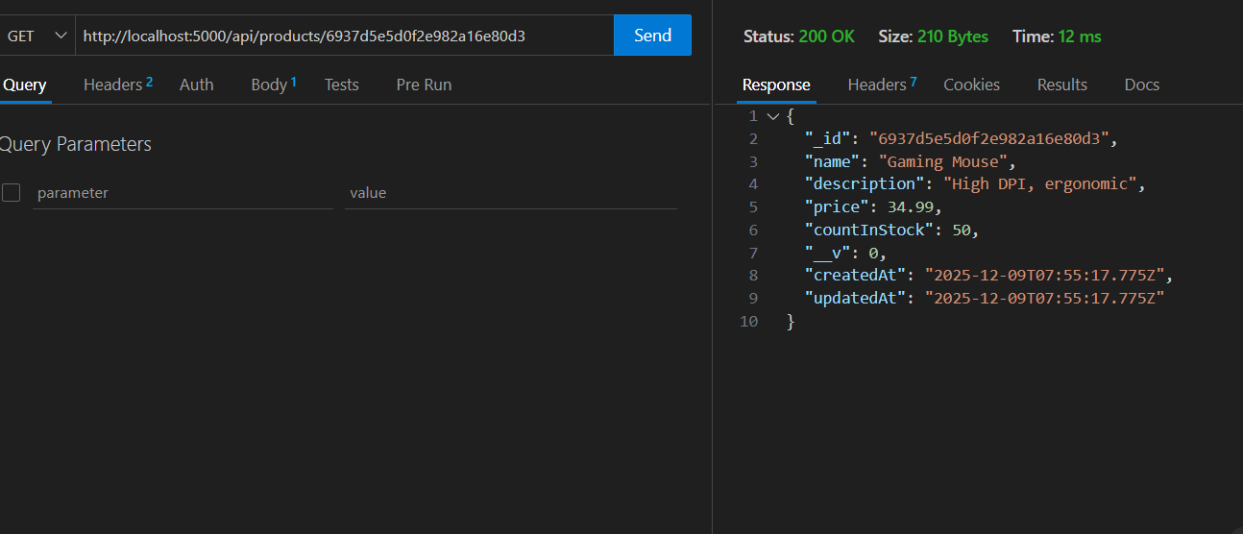

- Login of user. (POST)
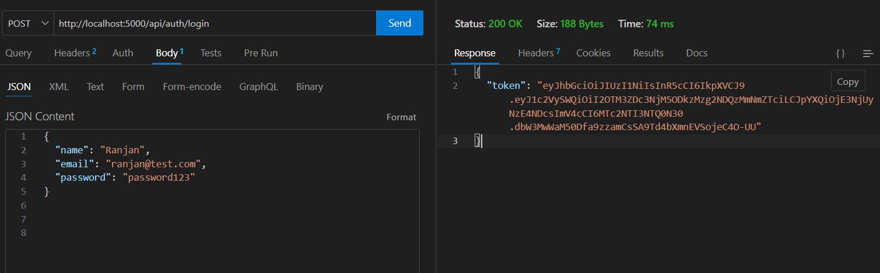
- Product adds to cart. (POST)
